**Advanced Database Management Systems**

**Experiment-5**

**Use of different SQL clauses and join**

**Aryan Mohan**

**500092142**

**Batch- 2**

CREATE DATABASE LabExperiment5;

use LabExperiment5;

CREATE TABLE DEPARTMENT ( DEPTNO INTEGER NOT NULL, DNAME VARCHAR(15) NOT NULL, LOC VARCHAR(30), PRIMARY KEY (DEPTNO) );

CREATE TABLE EMPLOYEE ( EMPNO INTEGER NOT NULL, ENAME VARCHAR(30) NOT NULL, JOB VARCHAR(20) NOT NULL, MGR INTEGER, HIREDATE DATE, SAL INTEGER, COMM INTEGER, DEPTNO INTEGER PRIMARY KEY (EMPNO), FOREIGN KEY (DEPTNO) REFERENCES DEPARTMENT(DEPTNO) );

insert into DEPARTMENT values(10, 'ACCOUNTING','NEW YORK');

insert into DEPARTMENT values(20, 'RESEARCH','DALLAS');

insert into DEPARTMENT values( 30, 'SALES','CHICAGO');

insert into DEPARTMENT values(40, 'OPERATIONS','BOSTON');

insert into EMPLOYEE values(7369,'SMITH','CLERK', 7902 , '17-DEC-80',500,800,20);

insert into EMPLOYEE values(7499, 'ALLEN','SALESMAN', 7698,'20-FEB-81',1600,300,30);

insert into EMPLOYEE values(7521, 'WARD', 'SALESMAN',7698, '22-FEB-81', 1250,500,30);

insert into EMPLOYEE values(7566, 'JONES','MANAGER', 7839,'02-APR-81',2975,0,20);

insert into EMPLOYEE values(7654, 'MARTIN', 'SALESMAN',7698, '28-SEP-81',1250,1400,30);

insert into EMPLOYEE values(7698, 'BLAKE', 'MANAGER',7839,'01-MAY-81',2850,0,30);

insert into EMPLOYEE values(7782, 'CLARK', 'MANAGER',7839,'09-JUN-81',2450,0,10);

insert into EMPLOYEE values(7788, 'SCOTT', 'ANALYST',7566,'09-DEC-82',3000,0,20);

insert into EMPLOYEE values(7839, 'KING', 'PRESIDENT',7599,'17-NOV-81',5000,0,10);

insert into EMPLOYEE values(7844,'TURNER', 'SALESMAN', 7698,'08-SEP-81',1500,0,30);

insert into EMPLOYEE values(7876,'ADAMS', 'CLERK', 7788,'12-JAN-83',1100,0,20);

insert into EMPLOYEE values(7900,'JAMES', 'CLERK',7698,'03-DEC-81',950,0,30);

insert into EMPLOYEE values(7902,'FORD', 'ANALYST',7566,'03-DEC-81',3000,0,20);

insert into EMPLOYEE values(7934,'MILLER', 'CLERK',7782,'23-JAN-82',1300,0,10);

select * from EMPLOYEE;

select * from DEPARTMENT;

-----Experimen 5

--1. List the Deptno where there are no emps.

select deptno, count(*) from employee group by deptno having count(*)=0;

Output:



--2. List the No.of emp’s and Avg salary within each department for each job.

select count(*),avg(sal),deptno,job from employee group by deptno,job;

Output:

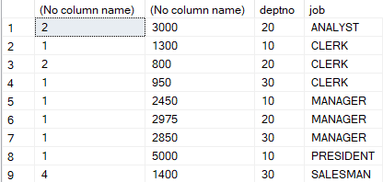

--3. Find the maximum average salary drawn for each job except for ‘President’.

select avg(SAL),job from EMPLOYEE where JOB!= 'PRESIDENT' group by JOB;

Output:

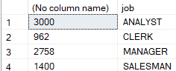

--4. List the department details where at least two emps are working.

select deptno ,count(*) from EMPLOYEE group by deptno having count(*)>=2

Output:

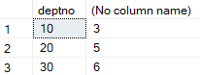

--5. List the no. of emps in each department where the no. is more than 3.

select deptno,count(*) from EMPLOYEE group by deptno having count(*)>3;

Output:



--6. List the names of the emps who are getting the highest sal dept wise.

select E.ename,E.deptno, E.SAL from EMPLOYEE E where E.sal in (select max(sal)from EMPLOYEE group by deptno);

Output:

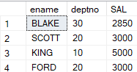

--7. List the Deptno and their average salaries for dept with the average salary less than the averages for all departments.

select deptno,avg(sal) from EMPLOYEE group by deptno having avg(sal)<(select avg(Sal) from EMPLOYEE);

Output:



---JOIN OPERATIONS

---Equi join

SELECT EMPLOYEE.EMPNO, EMPLOYEE.ENAME, EMPLOYEE.DEPTNO, DEPARTMENT.DEPTNO, DEPARTMENT.LOC FROM EMPLOYEE, DEPARTMENT WHERE EMPLOYEE.DEPTNO = DEPARTMENT.DEPTNO;

Output:

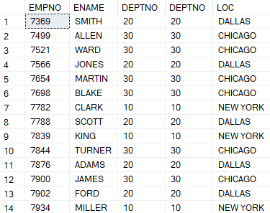

----Outer Joins

SELECT e.ENAME, e.DEPTNO, d.DNAME FROM EMPLOYEE e, DEPARTMENT d WHERE e.DEPTNO = d.DEPTNO;

Output:

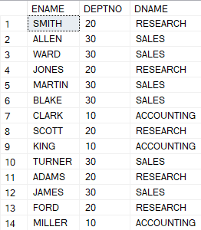

SELECT e.ename, d.DEPTNO, d.dname FROM EMPLOYEE e, DEPARTMENT d WHERE e.deptno =d.deptno ORDER BY e.deptno;

Output:

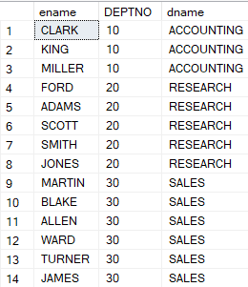

SELECT e.ename, d.DEPTNO, d.dname FROM EMPLOYEE e INNER JOIN DEPARTMENT AS d ON e.deptno =d.deptno ORDER BY e.deptno;

Output:

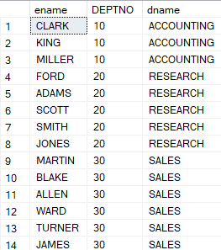

SELECT e.ename, e.EMPNO, e.SAL, d.deptno, d.dname FROM EMPLOYEE e INNER JOIN DEPARTMENT AS d ON e.deptno =d.deptno;

Output:

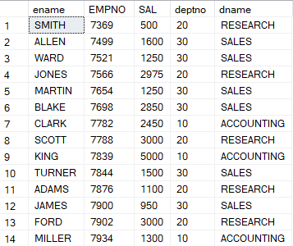

SELECT e.ename, e.EMPNO, e.SAL, d.deptno, d.dname FROM EMPLOYEE e LEFT OUTER JOIN DEPARTMENT AS d ON e.deptno =d.deptno;

Output:

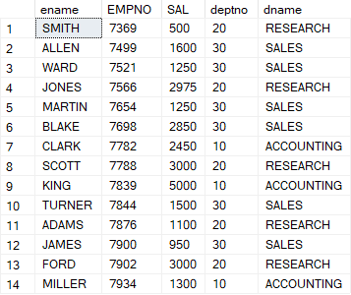

SELECT e.ename, e.EMPNO, e.SAL, d.deptno, d.dname FROM EMPLOYEE e RIGHT OUTER JOIN DEPARTMENT AS d ON e.deptno =d.deptno;

Output:

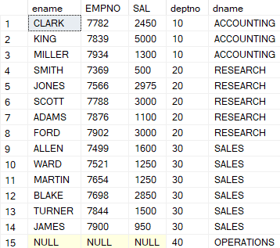

SELECT e.ename, e.EMPNO, e.SAL, d.deptno, d.dname FROM EMPLOYEE e FULL OUTER JOIN DEPARTMENT AS d ON e.deptno =d.deptno;

Output:

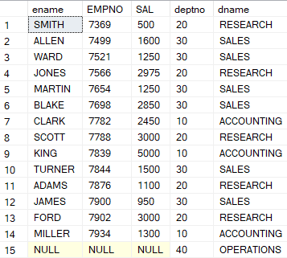

SELECT * FROM EMPLOYEE e FULL OUTER JOIN DEPARTMENT AS d ON e.deptno =d.deptno;

Output:

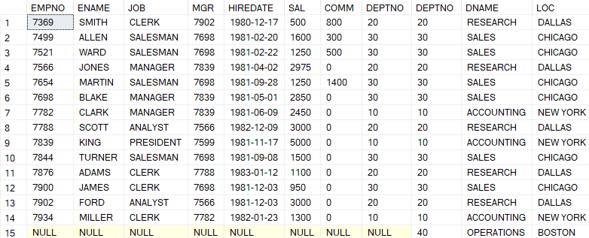

SELECT * FROM EMPLOYEE e RIGHT OUTER JOIN DEPARTMENT AS d ON e.deptno =d.deptno;

Output:

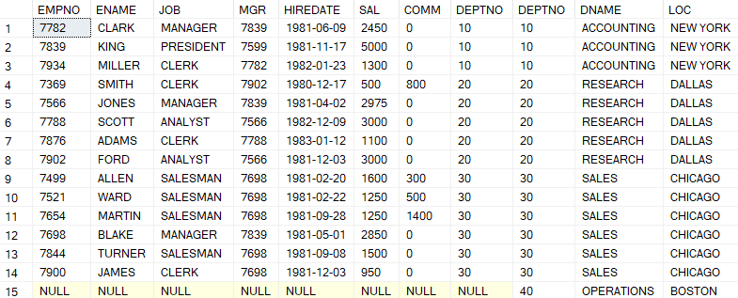

SELECT * FROM EMPLOYEE e LEFT OUTER JOIN DEPARTMENT AS d ON e.deptno =d.deptno;

Output:

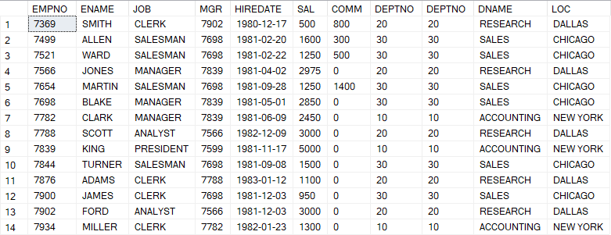

SELECT * FROM EMPLOYEE e INNER JOIN DEPARTMENT AS d ON e.deptno =d.deptno;

Output:

